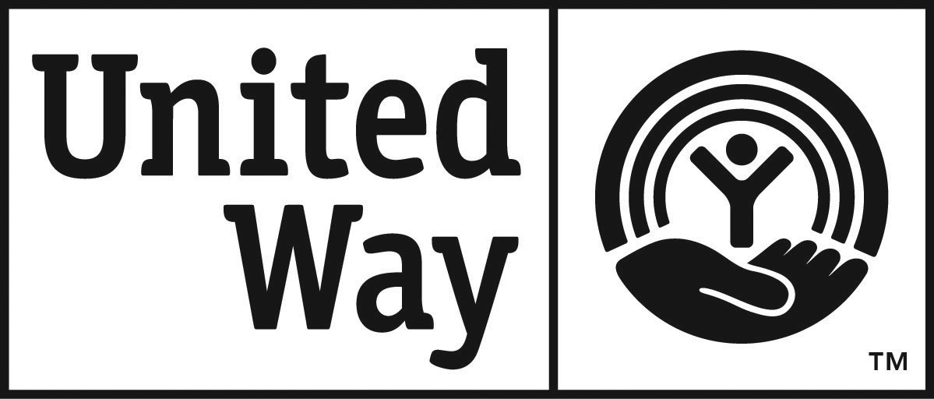
United Way of Passaic County
Vincent D. Pavese 2017
Scholarship Application

The Pavese Scholarship is a $1,500 scholarship to aid the recipient in attending an accredited college or university upon graduation from high school in Passaic County.

The individual must reside in and attend high school in Passaic County,
pursue a career in public service and must qualify for financial aid.

- APPLICATIONS ARE DUE BY Friday April 28, 2017

Applicant - please circle: Mr. or Ms.

First / Last Name: ______________________________________________________________

Address: _________________________________City:___________________________ Zip: ________

Telephone: _________________________ Email: _________________________________________

Your personal statement is a critical part of your application. Explain why you want to pursue a career in public service and which career/major you’ve chosen. Include your personal attributes that will help you achieve your goal.
(500 words): Attach typewritten and double-spaced essay to this page.

Your signature below attests to the accuracy of the information given and authorizes
publication of such information by United Way of Passaic County
in connection with the announcement of the scholarship recipient.
……………………………………………………………………………………………………………………………………………..,

Student’s signature: ______________________________________________Date: _______________________

High School: ______________________________________________________________________

Address of School: ___________________________________ City: ______________ NJ Zip: __________

HS Grade Point Average: ________________ Combined SAT Score __________________________

Guidance Counselor’s Signature: ___________________________________________________________

Guidance Counselor’s email: ___________________________________________________________________

Fax Number: _______________________ Phone #: _________________________________________________

- Incomplete applications will not be considered.

- Deadline: must be postmarked no later than Friday April 28, 2017

- Send completed application packet to:
Pavese Scholarship Coordinator
United Way of Passaic County
301 Main Street
Paterson, NJ 07505

- Questions? Email to: carolines@unitedwaypassaic.org

Refer to CRITERIA SHEET for required documents.

